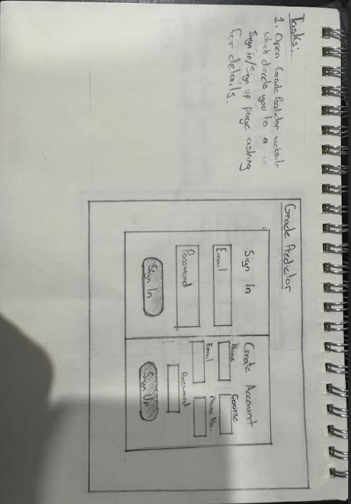

Sign In/Sign Up Page



Home Page

Edit Units Page

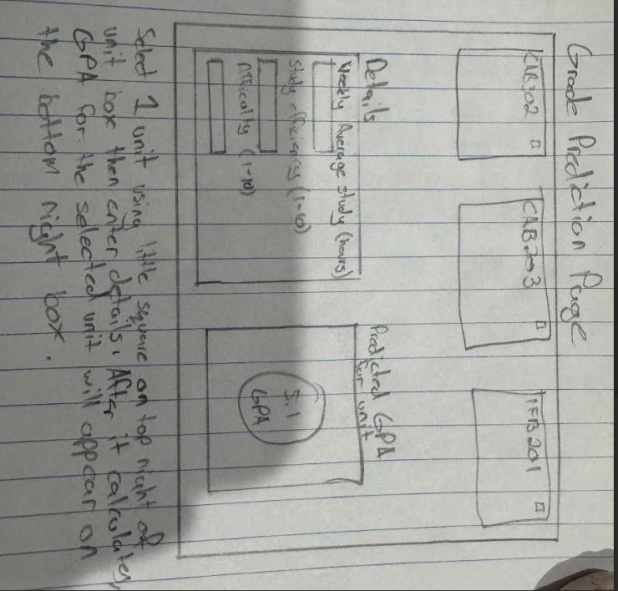

Grade Prediction Page